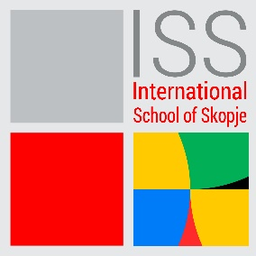

high school COUNSELLOR
DATE POSTED: 15/4/2024
International School of Skopje are recruiting a High School Counsellor to join. The High School Counsellor will be required to work as part of a team in the Assistant Principal Academic Office playing a leading role in college counselling for students in grades 9 to 12.
Main Responsibilities:
- To take the leading role in all educational and informational programs related to college counselling (e.g. student, teacher and parent workshops, open evenings, assemblies etc)
- To keep up-to-date on issues and trends related to university placement through professional development and attending conferences
- To be college counsellor for a group of students in grade 9, 10, 11 & 12 that will be divided amongst the college counselling department.
- To meet regularly and individually with students and families in his/her caseload
- To advocate for his/her students throughout their college application process
- To work with advisors to facilitate college application process including course selection
- To work with faculty to improve and standardise the quality of their advocacy letters
- To work with the English Department to help students develop application essays and personal statements
- To develop and maintain strong relationships with university admissions personnel through school visits
- To keep college placement records, produce reports about placements and update school profile
- To monitor 11th and 12th grade student schedules in relation to college applications
- To keep abreast of individual student status with regard to credits, academic warnings, honour roll etc
- To be available for parent conferences and “drop-ins” (“Open Door” policy)
- To represent International School of Skopje Academic office at off-campus events
- To maintain the ISS counselling web page
- To edit the school profile and college applications handbook
- To be jointly responsible, with all other high school staff, for promoting and safeguarding the welfare of children in the school.

Knowledge, skills and experience required:
- The ideal candidate will have had some previous teaching experience
- Positive personality, enthusiastic, flexible, team-player, tolerant, understands teenager behaviour
- Strong knowledge of UK, US and European colleges and universities
- An established network of admissions colleagues
- Educated to BA essential
- Experience working in high school college counselling essential
- Strong IT skills essential is preferred

SAFEGUARDING

ISS is committed to diversity, in terms of race, gender, religion, identity, or ability. We think that variety enables us to realize our vision, fulfill our purpose, and it reflects our values. As an ISS employee, you are expected to share ISS's dedication to preserving and advancing the wellbeing of young people.
Qualified candidates should submit the letter of interest and their CV, to the following email address: elena.stefanovska@iss.edu.mk, admissions@iss.edu.mk with „Subject” indication: College Counsellor
Only qualified candidates will be contacted for an interview.
The CV-s must be in English. The closing date for applications is 29.4.2024.

