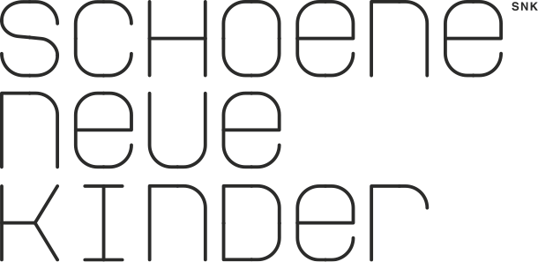

Frontend Developer (male/female)

You want to be part of a newly founded team in Skopje, which works closely together with its sister company in Munich, Germany? You want to work on exciting projects and use modern tools and technology like Composer, Docker, Jenkins, Git, Gulp, Grunt and Bower? You like professionally working in a team of web developers which takes DevOps and Scrum seriously, works agile and constantly develops? Our company is the right place for you!

SNK is a unique digital agency as we combine highest standards with a family atmosphere working culture and deep experience with fresh curiosity. We are a team of 100+ colleagues, owner-rund and fully digital. For our teams in Skopje and Munich we’re looking for motivated and talented Frontend Developers.

Your Expertise:
- Implementation of challenging (responsive) templates for complex websites and applications
- Very good skills in HTML5, CSS 3 and optional: JavaScript / AngularJS
- Close collaboration with UX Designers and Backend Developers
- At least 2-3 years of work experience
- Very good English language skills

What we offer:
- Exiting projects for international clients
- Personal career development incentives
- State of the art hardware
- Work in our beautiful offices in central Skopje and Munich – while earning an attractive salary

Are you interested?
We’re looking forward to your application!
Please write to: career@snk.de

