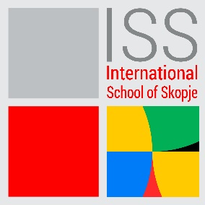

HIGH SCHOOL PRINCIPAL
DATE POSTED: 28/03/2023
International School of Skopje is looking for a High School Principal.
This role will lead, develop and manage the International School of Skopje in accordance with the School’s philosophy and objectives and the School Strategic Plan.

PRINCIPAL ACCOUNTABILITIES
• Implement the School’s philosophy and objectives
• Curriculum development and planning
• Assessment and evaluation
• Scheduling of students and teachers
• Student well being
• Staff management and development
• Evaluation of own performance and personal development

KNOWLEDGE, SKILLS & EXPERIENCE REQUIRED
- Commitment to excellence in education
- Understanding of and commitment to the Mission, Aims and Values of International School of Skopje
- Strong capability covering all sections of the Principal’s Job Description (see below).
- A proven track record as a successful teacher and educational leader within an international school setting.
- A high degree of emotional intelligence, allied with outstanding interpersonal skills.
- A collaborative approach to team working.
- Excellent communication skills in written and spoken C1 level English.
- Commitment to nurturing staff professional growth and supporting staff initiative.
- A creative and innovative approach to curriculum design and delivery.
- Commitment to nurturing student leadership and responsibility.
- A reflective and analytical thinker.
- An entrepreneurial problem-solver.
- Thoughtful commitment to the role of technology in supporting teaching and learning.
- A relevant Master’s degree (or equivalent qualification in school leadership) from an internationally-recognised university/college is preferred.
SAFEGUARDING
ISS is committed to diversity, in terms of race, gender, religion, identity, or ability. We think that variety enables us to realize our vision, fulfill our purpose, and it reflects our values. As an ISS employee, you are expected to share ISS's dedication to preserving and advancing the wellbeing of young people.
Qualified candidates should submit the letter of interest and their CV, to the following email address: admissions@iss.edu.mk, with „Subject” indication: High School Principal
Only qualified candidates will be contacted for an interview.
The CV-s must be in English. The closing date for applications is 12.04.2023.

