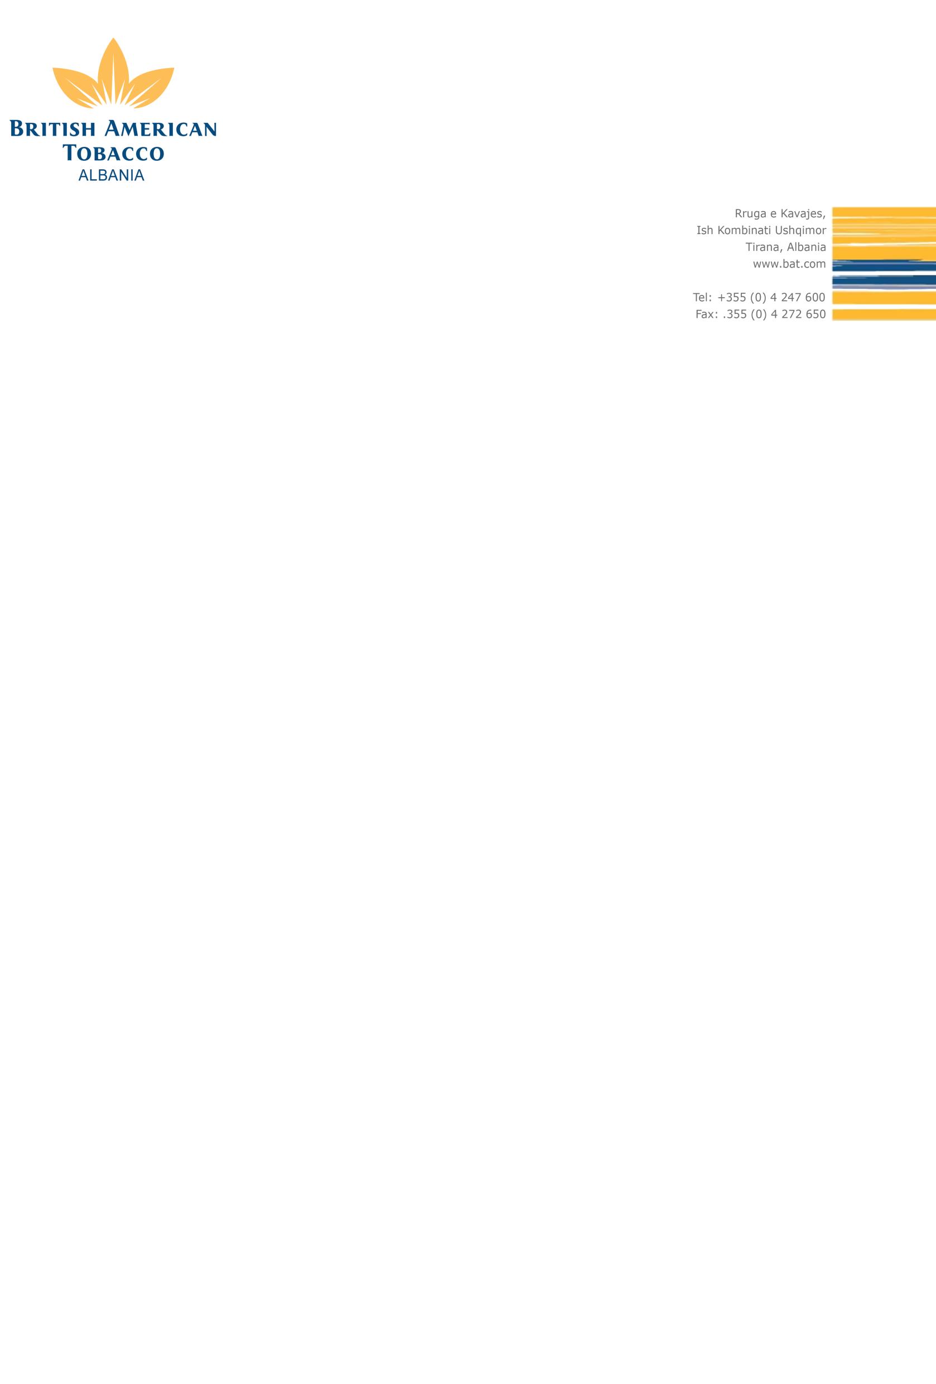

**British American Tobacco** (www.bat.com) is one of the world’s  
most international businesses with a portfolio of globally recognized brands, a culture of open-mindedness and a bright and dynamic future. Our aim is to become the leading tobacco company in each of our markets by providing excellent products with confidence and responsibility expected of global consumer brands.

If you have the talent and motivation to help us succeed you’ll find we are equally committed to helping you to reach your full potential too.

Currently we are in search for candidates for the position of

**IT Services Executive**

**Located in Skopje, Macedonia**

**Role holder’s responsibilities:**

Responsible for the delivery of agreed work products, resources, expertise and guidance in order to deliver the following:

* Provide first level support of commonly used software, hardware and other equipment within the organization – both on-site and remotely. Support of landing local/regional/global IT projects
* Manage the IT equipment and organize maintenance of IT assets - computers, laptops, mobile devices and IT office equipment for Albania, Kosovo and Macedonia
* Accurately log all tickets using the company provided Ticketing system; respond to all customer emails and calls in a timely manner;
* Ensures staff use agreed global, standardized IT Service Management processes;
* Understand business requirements and translate these into technical solutions;
* Managing Business critical application in terms of understand how they work, cooperation with application vendor and their respective resolver groups.
* Ensure effective evaluation of business risks and issues related to operational incidents, potential application changes and internal audit reports. Implement appropriate risk management processes and take appropriate and timely actions;
* Negotiate, agree and manage operational plans, service level agreements and budgets and monitor implementation to ensure targets are met.

## Skills & Experience:

* Ideally, Previous experience on similar positions min 1 year;
* Experience in large global organization using in-sourced and out-sourced IT services;
* Good understanding of Windows Active Directory, DNS, Microsoft Exchange & Outlook, Office 365, Teams and OneDrive;
* Experience with SAP will be considered as an advantage;
* Highly effective at quickly researching issues on internal knowledgebase and on the web;
* Good understanding of computer Networking concepts;
* Methodical analysis, troubleshooting and critical thinking skills;
* Very good English both written and verbal.





The position is on an employment contract with third party and working place is in the office of British American Tobacco in Macedonia.

If you are interested in this position please send your CV to the following address, until **05th of June 2020**

[ALMAKO_Recruitment@bat.com](mailto:ALMAKO_Recruitment@bat.com)

Only short listed candidates will be contacted.

All applications will be treated in strict confidentiality.

**Looking forward to receiving your application!**

**Your BAT Team**