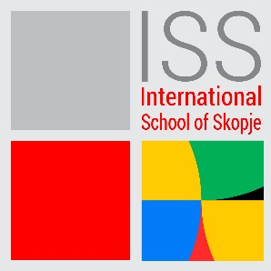

PUBLIC RELATIONS SPECIALIST
DATE POSTED: 24/1/2024
International School of Skopje is recruiting a Public Relations Specialist to join.
The Public Relations Specialist will be responsible for designing, maintaining and shaping the image of the school. Visual communication initiatives including print, videos, photos, website and social media are used to develop a positive impression of the school for in-school and out of school audiences. Responsible for creating all public presentations, speeches and letters for the principal and administrative team.
Principal Accountabilities:
- Meets regularly with the principal and leadership team to fully capture the culture and spirit of the school.
- Develops and maintains schools’ website and social media accounts.
- Captures major events at the school through photography, video, and editorials.
- Writes and prepares presentations and press releases, with the oversight of the principal.
- Analyzes media metrics and engagement to inform media strategy.
- Develops a marketing and communication plan including strategy, goals, budget and tactics, with oversight of the principals.
- Designs and creates marketing materials.
- Required to have prompt, regular attendance in-person and be available to work on-site, in-person during regular business hours and as needed.
- Performs other duties as assigned by an appropriate administrator or their representative.

Knowledge, Skills & Experience Required:
Qualifications:
Degree level required (education, marketing or related subject an advantage)
Able to develop admission and marketing information and correspondence with a high degree of accuracy
Experience:
- Understanding of and commitment to the Purpose, Vision and Values of International School of Skopje
- A high degree of emotional intelligence, allied with outstanding interpersonal skills
- Excellent communication skills in written and spoken C1 level English
- Strong communication and writing skills and editorial judgment.
• Understanding of requirements and distinctions of print, web, and broadcast design.
• Strong technical support and troubleshooting skills.
• Ability to speak publicly at interviews, conferences, presentations.
• Ability to work in a fast-paced environment, handle multiple tasks, respond effectively to unexpected challenges, and work both independently and collaboratively with team members and staff.
SAFEGUARDING
ISS is committed to diversity, in terms of race, gender, religion, identity, or ability. We think that variety enables us to realize our vision, fulfill our purpose, and it reflects our values. As an ISS employee, you are expected to share ISS's dedication to preserving and advancing the wellbeing of young people.
Qualified candidates should submit the letter of interest and their CV, to the following email address: elena.stefanovska@iss.edu.mk, admissions@iss.edu.mk with „Subject” indication: Public Relations Specialist
Only qualified candidates will be contacted for an interview.
The CV-s must be in English. The closing date for applications is 7.2.2024.

