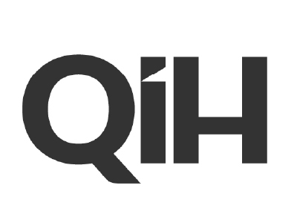

Head of HR

DO YOU LIKE TO WIN?
ARE YOU A TEAM PLAYER?
CAN YOU TEST, LEARN & OPTIMISE?
WILL YOU THRIVE IN A DATA DRIVEN ENVIRONMENT?
Summary

Job Title: Head of HR
Location: Skopje
Salary: TBC
Department: HR

Who we are

QiH is a group of companies focussed on digital marketing within the gaming sector. We are a young, innovative and progressive business with staff across offices in Skopje and London. We are specialists in Customer Acquisition and Retention, Search Engine, Social & Affiliate Marketing and Data & Analytics. We are an international business active in multiple markets around the globe.

Our Company Values

- We Are Here To Win
- Play As A Team
- Embrace Processes & Make Them Better
- Make Decisions & Solve Problems Based On Data
- Be Accountable & Take Responsibility
- Test & Learn, Make Mistakes, Optimise
- Respect, Understand & Help Each Other

The role

We are looking for a senior HR professional to lead our HR function and be part of the senior leadership team in the Skopje office while also working closely with our UK office and helping to guide the Group’s HR strategy. The role will include taking ownership of all elements of HR from both a transformational and transactional perspective including recruitment, induction, training & development and administration.

Responsibilities

HR

- Play a lead role on the leadership team within the Skopje office and develop strong relationships with the senior management in both the London and Skopje offices
- Manage and develop the recruitment process working with internal stakeholders to run advertising and selection programmes that identify the best candidates
- Take a lead role in induction programmes helping internal stakeholders integrate new recruits into the business
- Manage all staff-related legal and administrative tasks including employment contracts, health & safety requirements and employment compliance obligations
- Oversee staff assessment activity including annual appraisals, performance reviews and development plans
- Manage and develop the internal training programme to ensure all staff training needs are met
- Be responsible for collecting and analyse HR data via staff questionnaires and software tools and share insights with internal stakeholders
- Maximise the relationship with external HR consultants the business contracts with
- Plan staff incentive and entertainment initiatives and programmes to help maintain high morale
- Ensure the office environment is an attractive place to work

Admin

- Ensure all HR-related documents are appropriately and securely filed and stored in accordance with local legal and data protection requirements
- Help manage local payroll
- Ensure that all government mandated HR reporting requirements are met
- Manage the absence process ensuring that all work absence is recorded and tracked and that relevant data is shared with internal stakeholders
- Ensure the office is adequately stocked with general supplies including water and cleaning products
- Manage visa application process for UK travel for Macedonian staff
- Mange orders for office furniture, provisions and other general stock

Skills, Experience and Qualifications

- Strong communication and interpersonal skills
- Fluent English language skills, both spoken and written
- Good administrative and organisational skills
- At least 5 years’ experience working in an HR or equivalent role
- Excellent people management skills with experience of managing teams of people in a professional capacity
- Leadership experience with proven track record of regular dealing with C-suite executives
- Trustworthy, discreet and loyal
- Good conflict management skills and the ability to manage competing interests to keep multiple parties happy
- HR qualifications an advantage
- Good knowledge of local employment and labour laws and regulation and compliance requirements
Benefits
- Competitive Basic Salary + Bonus
- Private Health Care
- Long-Term Incentive Plan
- International Travel Opportunities
- Annual Company Conference
- Regular Business Happy Hour & Team events
- Loyalty Packages
- Fit Kit Wellness Application
- Ongoing training, development and certifications
- Soft skills training with a professional consulting company
- In-house, bespoke training Academy
- Free drinks & coffee

