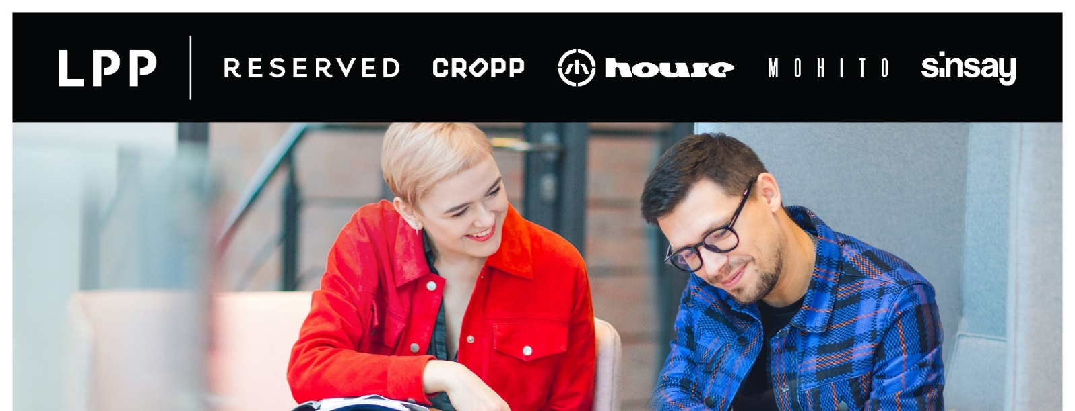
We are an international company which has been successfully operating in the clothing industry for over 20 years. We manage five recognisable brands: RESERVED, CROPP, HOUSE, MOHITO and SINSAY.
Through our network of nearly 1,700 stores, we reach millions of customers in Europe, Asia and the Middle East. In our offices and sales structures, we create jobs for more than 25 thousand people.
Currently we are looking for:
Logistics Manager
North Macedonia, Skopje office
MAIN RESPONSIBILITIES:
- Managing customs procedures and cooperates with external partners (forwarding agents, external warehouse and transportation companies)
- Inventory execution
- Loss prevention process support
- Delivery responsibility
- Transfers organization
- Warehouse and stock responsibility
- Creating documents for merchandise transfers and customs
- Monitor the workplace to assess safety issues or concerns
- Supporting sales and investment department in terms of stock and deliveries
- Supporting changes processes and communicating them to all stores
- Ordering of necessary equipment and supplies for offices and stores, including cooperation with printing house according to local needs for POS material
- Partner with other departments (investment, maintenance, marketing and sales)

OUR EXPECTATIONS:
- minimum 2 years of professional experience
- minimum higher education
- fluent in English
- good knowledge of MS Office (Word, Excel, PowerPoint)
- ability to build a cooperation and trust with business partners
- communication skills
- high level of organization of their own work and self-reliance in action
- proactive attitude in problem solving and creativity

WE OFFER:
- Stable position within a well-established company in textile industry
- Opportunity to participate in international projects
- Dynamic working environment,
- Career growth opportunities
- Competitive salary
- Performance-based bonus
Please send your CV in English
Only shortlisted candidates will be contacted.

