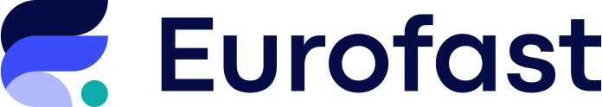

Eurofast, a leading regional business advisory firm, is looking for a licensed Authorized Accountant to join our expanding team. If you're passionate about accounting and want to work in a dynamic environment — we want to hear from you!

🔍 What You’ll Be Doing
- Managing full-cycle bookkeeping and accounting
- Preparing financial statements, internal management reports, and statutory annual filings
- Providing advisory services on accounting and tax matters
- Communicating daily with tax authorities, and internal teams across borders
- Staying updated on changes in relevant legislation

✅ What We’re Looking For
- Licensed Authorized Accountant (mandatory)
- University degree in Accounting, Finance, or related field
- Minimum 3 years of professional experience in accounting
- Fluent in English (knowledge of Greek will be considered an advantage)
- Strong communication, analytical, and interpersonal skills
- Advanced computer literacy and comfort with online systems
- Experience with international tax matters or cross-border training is a plus

🌍 Why Join Eurofast?
- Work with international clients and cross-border projects
- Be part of a collaborative and forward-thinking team
- Gain exposure to complex, high-impact accounting and tax issues
- Competitive salary and continuous professional development opportunities
- A company culture that values expertise, integrity, and innovation

Ready to advance your accounting career with Eurofast?
Apply now and become part of a company where your skills make an impact.
📧 Submit your CV to skopje@eurofast.eu
🗓️ Deadline: 06.10.2025

