Job announcement
Company | ITD Distribucija Doo Skopje
Department | Enterprise
Title | Senior technical pre-sales engineer (Dell Technologies)
Introduction:

ITD Distribucija DOO Skopje is seeking to recruit Senior technical pre-sales engineer (Dell Technologies).
This is an excellent opportunity for you to join a regional leading distribution company.
ITD Distribucija Macedonia is part of Infosoft Group. The company has started operating in the Macedonian market since 2007 dealing with distribution of IT products and distribution of Paper and Graphic Materials.
During our 15 years of business with distribution, we have achieved the fastest growth not only for InfoSoft Group but also for the eastern European region. In recent years despite the global economic crisis, we have high performance in our operations. Aspiring for high performance while taking into consideration market realities, focusing on punctual distribution process, qualitative relationship with partners, high business ethics, professionalism and knowledge in sales/management, and perfect logistics, ITD Distribution has the objective to be a market leader in the IT distribution market in Macedonia.
An excellent opportunity for development and growth of your career in one of top regional distribution company.
This role is suitable for senior level candidates.

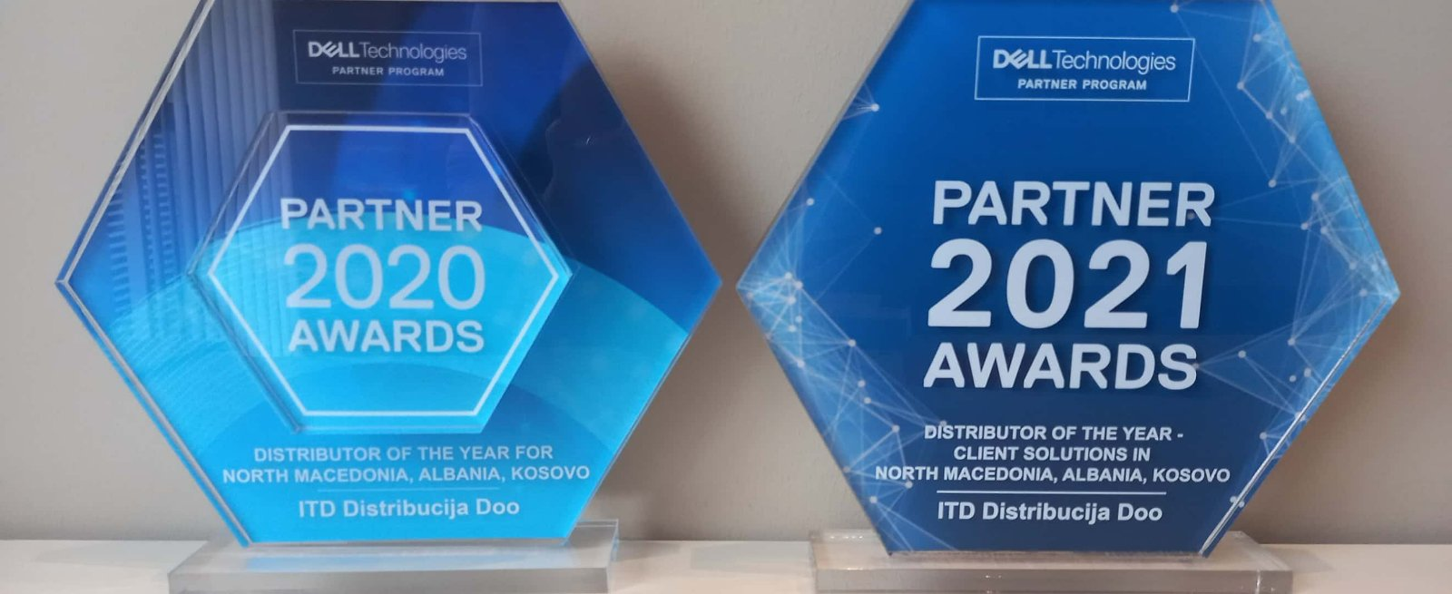
What You’ll Do
- As a Pre-sales engineer your activities will be based on the Dell (legacy EMC) vendor portfolio;
- Daily quoting of variety of data center related solutions (storage, server, back up infrastructure configuration) through the different manufacturer provided platforms, tools and solution sizing utilities;
- Lead partners through technical specification requirements and solution positioning;
- Assist with partner led data center design activities and projects;
- Practice continuous education and training in the related technologies, such as cloud workloads, converged / hyperconverged infrastructure, data protection, networking and servers;
- Work closely with all team members to interpret and evolve requirements into product features;
- Plan, organize and prioritize personal as well as team workload.
What You’ll Need to be Successful
- Formal education from a technical university;
- At least 5 years of experience in related IT technologies;
- Deep knowledge of server and storage technologies and solutions;
- Experience working with Dell/EMC product portfolio is an advantage;
- Having Dell / EMC or any other storage or server vendor’s certificates is an advantage;
- You should have a positive attitude and excellent communication skills to effectively share your knowledge;
- Be able to operate effectively in a team environment with both technical and non-technical team members and deliver projects on time;
- Good team player with excellent interpersonal & communication skills;
- Excellent verbal and written communication skill in English Language.

What you can expect from us

- In addition to a competitive base salary, this position provides incentive compensation that rewards the individual based upon assigned objectives. Statutory benefits also provided in accordance with local laws and practice;
- Great opportunity to join a Balkan wide recognized & market leading company - Infosoft Group is amongst the top IT Distributors with more than 30 years of experience;
- Liberal and enriching environment for experiencing state-of-the-art technologies, by working closely with the industry leading vendors;
- Carrier development and professional challenges;
- Excellent work environment;
- Additional private health insurance.
Qualified candidates should submit the letter of interest and their CV, to the following email address: career@itd.mk, with „Subject” indication: “Technical Solutions Architect”
Only qualified candidates will be called on interview.
The CV-s must be in English. The closing date for applications is 28.10.2021.

The personal information that you will submit through your application, will be protected and used only for recruiting purposes, according to the legislation for the protection of personal information, the Law on Personal Data Protection ("Official Gazette of the Republic of Macedonia" No. 7/05, 103/08, 124/08, 124/10, 135/2011, 43/2014 and 153/15).

