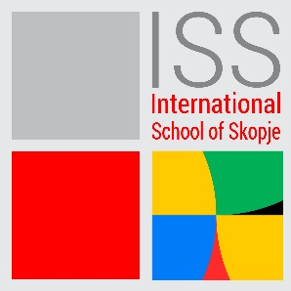

HEAD OF ADMISSIONS
DATE POSTED: 28/03/2023
International School of Skopje is recruiting a Head of Admissions to join.
The Head of Admissions will be driving student enrolment by leading the School’s Admissions function and actively participating in marketing programmes. You will act as an ambassador for the school and the wider International School of Skopje to prospective students and their families, relocation agents, education consultants, business representatives, school visitors and the general public.
This role sits as part of the School Leadership Team, managing enrolment planning and data interpretation, assisting families in their international relocations, admission and transition into the school, and works closely with Marketing to support the delivery of marketing and enrolment strategies.
Principal Accountabilities:
- Managing Admissions
- Managing Re-enrolments
- Leading the Admissions Team
- Contribute to the School Leadership and broader ISS Team
- Maintain and develop the Financial Assistance Programme
- Keep up-to-date with School developments and wider ISS
- Marketing and Business Development Management
- Information and Forecasting

Knowledge, Skills & Experience Required:
Qualifications:
Degree level required (education, marketing or related subject an advantage)
Able to develop admission and marketing information and correspondence with a high degree of accuracy
Experience:
- Understanding of and commitment to the Purpose, Vision and Values of International School of Skopje
- A high degree of emotional intelligence, allied with outstanding interpersonal skills
- Excellent communication skills in written and spoken C1 level English
- Self-reflective, with interest in encouraging self-reflection in others
- Readiness to be accountable for mistakes, seeing them as an opportunity for growth
- Ability to contribute diverse perspectives to the leadership of the school
- A reflective and analytical thinker
- An entrepreneurial problem-solver
- Resilience in the face of challenges and adversity
- Team management
- Budget management & business / sales skills
- Proven experience in use of databases and general IT applications and production / interpretation of statistical information and reports
- Previous Admissions experience in an international school environment an advantage Understanding/experience with IB programmes (especially IBDP and IBCP) and AP’s an advantage
- Experience working in a busy, hands-on customer/family service environment and delivery of outstanding customer/family experiences
- Handling sensitive and confidential data

SAFEGUARDING
ISS is committed to diversity, in terms of race, gender, religion, identity, or ability. We think that variety enables us to realize our vision, fulfill our purpose, and it reflects our values. As an ISS employee, you are expected to share ISS's dedication to preserving and advancing the wellbeing of young people.
Qualified candidates should submit the letter of interest and their CV, to the following email address: admissions@iss.edu.mk, with „Subject” indication: Head of Admissions
Only qualified candidates will be contacted for an interview.
The CV-s must be in English. The closing date for applications is 12.04.2023.

