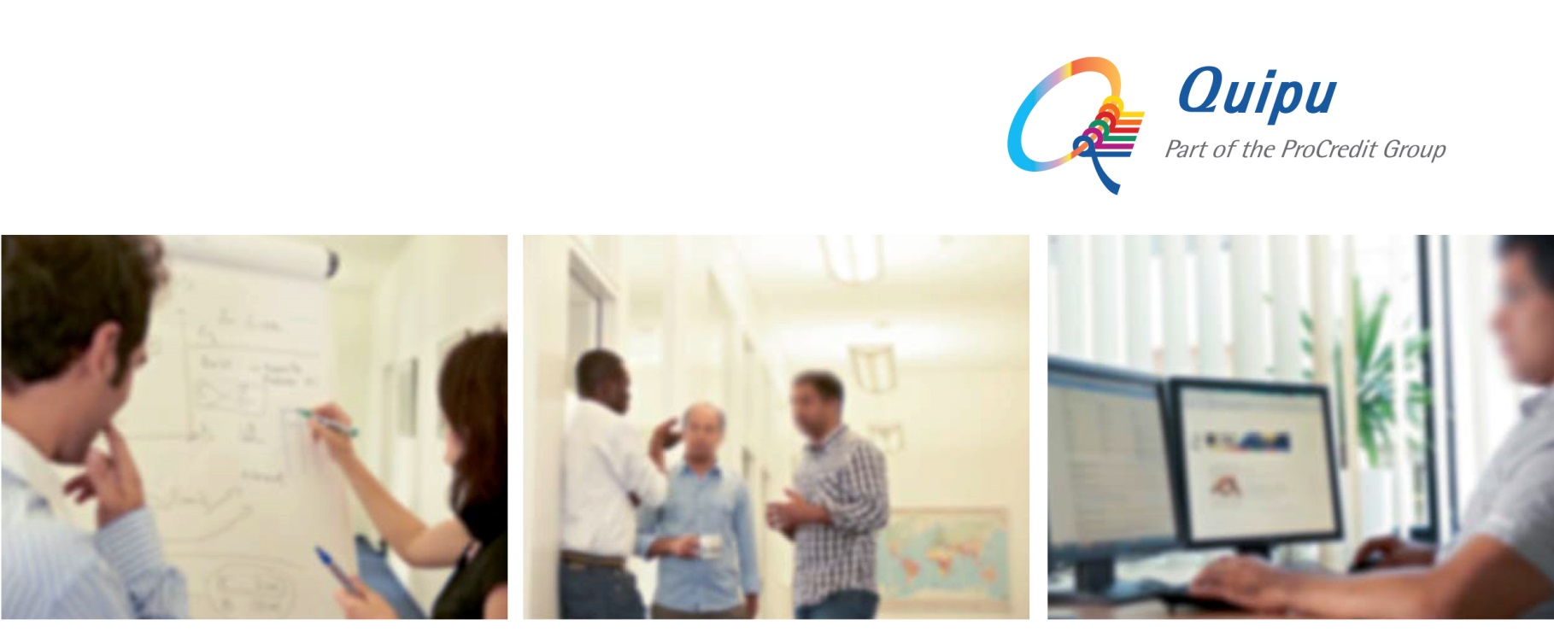
Quipu is an IT consultancy and software development company which provides comprehensive end-to-end solutions for banks and financial institutions, from electronic payments to software systems. We are a 100% subsidiary of ProCredit Holding, the parent company of a group of banks that specialize in providing financial services for SMEs.
Headquartered in Frankfurt, Germany, Quipu currently operates from 8 regional offices around the world - in El Salvador, Ecuador, Ghana, Macedonia, Kosovo, Ukraine, Russia and Romania - enabling us to promptly address the needs of a global customer base.
For our office in Skopje, North Macedonia, we are looking for an experienced, motivated and enthusiastic:
.NET Software Developer (m/f)
Job-ID: 19028
To join our international team at the earliest possible date.
Main tasks and responsibilities:
- Developing financial software following established standards and best practices by using .NET technology in Azure environment
- Analyzing and understanding a whole solution, with the interfaces and dependencies between the technical components
- Designing a technical solution based on business requirements defined by our customers
- Implementation of software solution in accordance with company standards and policies
- Continuous improvement of technical and business/financial knowledge
Requirements & attributes:
- Bachelor in Computer Science or Information Science
- .NET development experience with C#
- Experience with automated test and continuous integration
- Demonstrate complex problem solving, critical thinking, and decision-making
- Ability to design and document complete solutions
- Demonstrate flexibility and adaptability to ambiguity
- Demonstrate strong written, verbal, and interpersonal communications skills
- Demonstrate attention to detail and time management skills
- Experience with SQL Server and/or Azure and development of enterprise level N-tier solutions is considered as advantage
- Knowledge of banking business is a plus

Our offer:
- A substantial degree of flexibility, allowing for an autonomous approach to performing duties
- Challenging and varied work
- Flat management structure
- Long-term prospects with plenty of opportunities for professional development and growth
- Excellent team-oriented and international working environment
If you think you fit the profile, we look forward to receiving your application in English, including your CV, a motivation letter and salary expectations via the following e-mail address:
recruitment@quipu.de
The deadline for the submission of applications is 1st September, 2019. Please include the Job-ID in your application.

