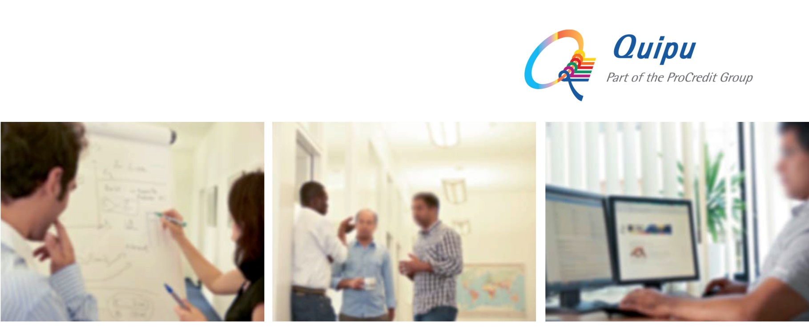
Quipu is an IT consultancy and software development company which provides comprehensive end-to-end solutions for banks and financial institutions, from electronic payments to software systems. We are a 100% subsidiary of ProCredit Holding, the parent company of a group of banks that specialize in providing financial services for SMEs.
Headquartered in Frankfurt, Germany, Quipu currently operates from 8 regional offices around the world - in El Salvador, Colombia, Ghana, Macedonia, Kosovo, Ukraine, Russia and Romania - enabling us to promptly address the needs of a global customer base.
For our office in Skopje, Macedonia we are looking for a motivated and enthusiastic:
Junior Application Programmer Analyst
Job-ID: 18016
to join our international team at the earliest possible date.
Main tasks and responsibilities:
- Develop software modules of the core banking system following standards and practices, in team together with the senior developers
- Implementation and maintenance of software solutions in accordance with company standards and policies
- Provide support, testing and training during implementation for the end-users of solutions
- Resolve and/or provide assistance in case of production incidents to re-establish the service as quickly as possible
- Maintain professional and technical knowledge by attending educational workshops; reviewing professional publications; establishing personal networks; participating in professional societies
Requirements:
- Bachelor Degree in Computer Science
- Good knowledge of T-SQL and MS SQL server
- Good knowledge of C# and OO design
- Basic knowledge of N-Tier architecture
- Experience developing applications using .NET technologies
- Basic knowledge in WPF is considered a plus
- Basic knowledge of XAML markup language is considered a plus
- Basic understanding of scripting languages (Python) is considered a plus
- Basic knowledge of design patterns – Repository pattern, MVVM pattern is considered a plus
- Basic knowledge of WCF is considered a plus
- Basic understanding of code versioning tools, Team Explorer is considered a plus
Our offer:
- A substantial degree of flexibility, allowing for an autonomous approach to performing duties
- Challenging and varied work
- Flat management structure
- Long-term prospects with plenty of opportunities for development and growth
- Excellent team-oriented and international working environment

If you think you fit the profile, we look forward to receiving your application in English, including CV, motivation letter, and salary expectation, at the following e-mail address:
recruitment@quipu.de

The deadline for receiving of applications is 16 April 2018. Please include the Job-ID and the city you apply for in your application.

