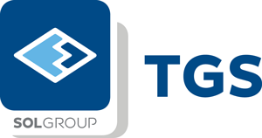
TGS Tehnički gasovi is a part of SOL group, one of the leading operators in the field of technical and medical gases, with successful operations worldwide. In line with the continuous expansion of our local activities, we are searching for a result oriented and proactive person for the position of

Medical Representative

Requirements:
- university degree in Pharmacy, Medicine or Stomatology
- fluency in English
- willingness for field work, active driver
- strategic thinker, flexible and adaptable with high business acumen
- high achievement drive

Responsibilities:
- sales of medical gases through daily visits and presentation of the product portfolio
- continuous market research
- creating of well developed network of potential customers (medical institutions, hospitals, clinical centres, medical doctors, etc.) for assigned portfolio
- contact with medical staff as end users as well as medical institutions’ technical and purchase departments
- competitors’ monitoring and understanding customer needs for company product line
- regular reporting on activities and client database update

We are offering you the opportunity to become a part of successful international company, with stable growth, along with the possibility for further professional development.
If you believe you can contribute to securing stabile development of our activities on the local market, please send your CV and application letter in English exclusively to our HR Consultant's address. Full confidentiality is guaranteed.
HILL International, Ul. Anastas Mitrev 26/4 Skopje
tel: +389 2 3296 481
e-mail: apply.macedonia@hill-international.com
https://www.hill-international.com/en-MK/

