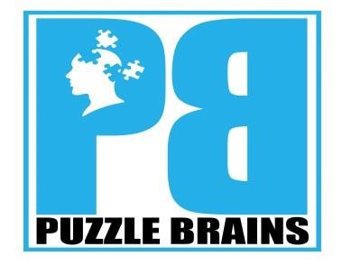

Puzzle Brains DOOEL Bitola is currently looking for

**Logistics Coordinator & Customer Support Agents**

**What we are looking for:**

- Advanced or proficient knowledge of the English language

- Basic computer skills

- Highly motivated people with the ability to perform well under pressure

- Flexible and organized people with a passion for success

- No prior work experience is needed

**What we are offering:**

- Paid training

- Equipment needed to perform the daily tasks

- Positive teamwork environment

- An opportunity to expand your communication, leadership and negotiation skills

- Great Salary and Bonus structure.

If you are interested, we invite you to submit your CV and be a part of our amazing journey.

Contact info: 070-333-565; puzzlebrains2016@gmail.com